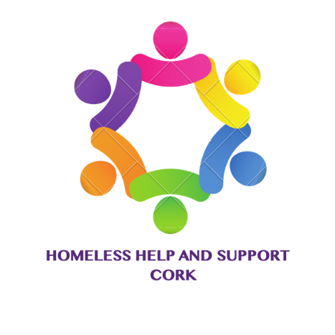

Volunteer Form

Contact Details
Name
Mobile No.
Email
Address
Next of Kin name
Next of Kin Phone No.

Area of interest in Volunteering – Please Tick (Qualification required for parts marked *)
Fundraising | Catering | On Street Work
Administration | Legal Advice * | Financial Advice *
Stock/food sourcing | Medical * | Transportation(van/car)
Sponsorship | Counselling * | Other (please specify)

Qualifications That may help Organization
GARDA VETTING IS REQUIRED FOR ALL VOLUNTEERS
IMPORTANT
Homeless Help & Support Cork store your personal data to have a volunteer and next of kin contact list in case it is necessary to contact you. If you consent to us storing your personal data for this purpose please tick the check box below.

Please tick if you agree to Homeless Help & Support Cork’s storage of your personal data

Signature: _____________________________ Date: ______________________

